Subtle Yoga
Yoga Sukshma Vyayama
of
Dhirendra Brahmachari

Sequences

1. Buddhi tatha Dhrti Shakti Vikasaka (Developing the mind and will power)

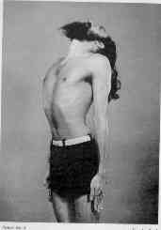

POSTURE: With your feet together, the body erect and the mouth closed, tilt
your head back as far as it will go and keep the eyes wide open. EXERCISE :
Concentrating on the crown of your head, inhale and exhale rapidly and vigoro-
usly through the nose with the bellows method. 25 times will suffice to begin
with.

2. Smarna Shakti Vikasaka (Developing the memory)

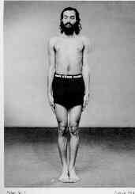

POSTURE: With your feet together, the body erect and the mouth in the normal
position and the eyes must focus on a spot of 5 ft. in front of the toes.
EXERCISE: Concentrate on the Brahma-randhra, which is the Yogic name for the
area just under the anterior fontenellae and through the nose inhale and
exhale vigorously (bellows effect). 25 times to begin with. This is of spe-
cial benefit to cases of mental fatigue. There is a marked improvement in
memory. This exercise is useful for all those whose work causes mental strain
and nervous exhaustion.

3. Medha Shakti Vikasaka (Developing the intellect)

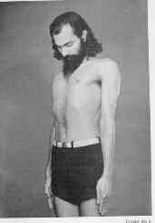

POSTURE: Close your eyes, keeping your feet together and your back erect.
your chin should be lowered to rest on the sternal notch. EXERCISE:According
to Yogic science, the centre of intellectual vigour is in the depression
at the back of the neck. Concentrate on this with all the force you possess
Then start the bellows breathing exercise inhaling and exhaling with equal
force. In the beginning 25 times.

4. Netra Shakti Vikasaka (Improving the eye-sight)

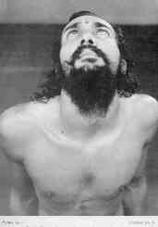

POSTURE: Stand with your feet close together, your back erect and your head
tilted back as far as it will go. EXERCISE: Concentrate with all your will,
while looking at the spot between your two brows without blinking. The eyes
must squint in doing so. When your eyes feel tired or start watering, discon-
tinue the exercise and resume it after a short rest. For five minutes in the
beginning. This inercine produces stimulation of the nasocialiaryplexus of
the autonomic nervous system, as well as on the fibres of the nerves moving
the eye-ball and internal structures of the eye. It improves themuscular
power, balance and co-ordination of the various muscles that move the eye-ball
It also exercises the muscle of the iris which constitutes the muscular dia-
phragm surrounding the pupil of the eye and is instrumental in increasing or
decreasing the amount of light entering the eyes and falling on the retina.
Gazing at one point also helps in putting into action the muscles which are
attached around the lens of the eye and whose contraction or relaxation result
in changing the shape of the lens,required for accurate focussing of the light
on the retina to form a sharp image of the observed object. Thus the entire
neuro-muscular apparatus of the eye-ball is toned up for a better perfor-
mance and endurance. This exercise, apart from having an immediate utility
for the eyes, has an even more important effect in training in the methods of
concentration of the mind.

5. Kapola Shakti Vikasaka (Rejuvenating the cheeks)

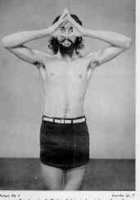

POSTURE : With feet close together and standing erect, join the tips
of the fingers and close the nostrils with the two thumbs. EXERCISE :Keeping
the eyes open and pouting your lips (in the shape of crow's beak),suck in the
air vigorously through the mouth with a sibilant sound and blow out your
cheeks. Now close your eyes and with your chin resting against the cavity of
your throat (sternal nothch),hold your breath as long as you can. Let the neck
return to the normal posture,open your eyes,and exhale through the nose slowly
and effortlessly. In the beginning five times. The Kakimudra depends on acra-
tion and oxygenation of the oral cavity. Since in normal breathing the mouth
remains closed and fresh air does not enter it, germs multiply unhindered. If
however, a frequent forceful jet of air falls on the teeth, gums etc., it must
have a beneficial effect and many oral infections would be prevented and cured
.Pouting and holding the mouth in that shape for some time as also puffing out
the cheeks would exercise most of the muscles of the face which ordinarily are
inactive except for the mild action involved in speaking or eating. The habi-
tual inaction of these muscles makes them flabby. It gives your cheeks a fresh
bloom. The teeth become stronger. Pyorrhoea, caries and halitosis are cured.
Sunken cheeks fill up gradually and once again look normal. Pimple, boils etc.
disappear.

6. Karna Shakti Vikasaka (Improving the hearing)

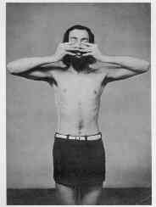

POSTURE : With the feet close together, stand erect. EXERCISE : Close your
mouth,plug your ears with the thumbs and place your index fingers on your eyes
which should be kept shut. Your middle and third fingers should encircle the
mouth which should pout so as to resemble the beak of a crow. Now suck in the
air, blowing out your cheeks and lower your chin to rest on the cavity of your
throat. Hold the breath as long as possible. Then let your neck go back to the
normal posture and while doing so open your eyes gradually and at the same
time exhale through the nose. Note that while holding the breath the cheeks
should be kept fully puffed out. The creation of pressure inside the mouth
forces air through the pharyngo-tympanic tube (eustacin tube) which connects
the mouth cavity with the middle ear. The healthy functioning of this tube is
essential for equalisation of pressure inside and outside the ear.Without this
the free vibrations of the ear drum cannot take place,which will result in
defective hearing. The Jalandharabandha (bent neck) which forms part of the
whole process ensures stimulation of the endocrine glands as well as nervous
components, both somatic and autonomous, situated in this region. "By closing
your ear-holes, nostrils, eyes and mouth you purify the passage of sound and
then you hear the pure (inner) sound".

7. Griva Shakti Vikasaka (Strengthening the neck)
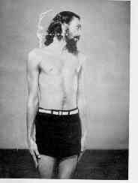

POSTURE : Keeping your feet together, stand erect. EXERCISE `A': Relaxing your
neck, turn your head with a jerk first towards your right shoulders, then
towards your left shoulders. In the beginning 10 times. EXERCISE `B': Standing
erect, jerk your head first forward,then backward. When it goes back it should
touch the nape of your neck. When it is forward your chin should touch the
sternal notch. Keep breathing normally. 10 times to begin with.

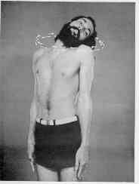

POSTURE : Keep your feet close together, your back straight, your mouth closed
and your eyes wide open. EXERCISE : Keep your chin in and rotate the head from
left to right and then right to left alternately. Breathe normally. Try to
make your ear touch your shoulder, taking particular care to avoid raising the
shoulder. Five times to begin with.
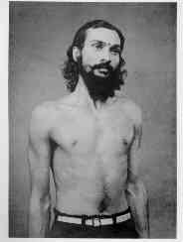

POSTURE : Keeping your feet close together, stand straight. EXERCISE : Inhale
and exhale through the nose ("Bellows effect") making the veins of your neck
stand out. Blow out your stomach while inhaling, draw it in while exhaling.25
times to begin with. This triple exercise strengthens the neck and beautifies
it. Diseases peculiar to the throat, such as tonsilitis, laryngitis, pharyngi-
tis etc. can be checked. The voice becomes resonant and speech defects such
as lisping and stammering are completely removed. With perseverance,this exer-
cise, in conjunction with a couple of others, yields marvellous results in
cases of dumbness. Singers will derive great benefit from it.

8. Skandha tatha Bahu-mula Shakti Vikasaka (Developing the strength of shoulder blades and joints)

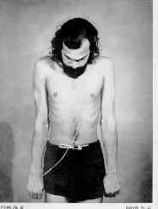

POSTURE : Feet close together, your back straight, your fingers clenched into
fists with the thumbs tucked in. EXERCISE: With your mouth pouting and forming
the shape of a crow's beak, suck in air, blowing out your cheeks and hold
your breath with your chin resting on the sternal notch. While holding your
back straight move the shoulders vigorously and stiffly up and down,in a pump-
ing motion. The arms should be kept rigidly straight at the side. Assume the
normal posture and straightening your neck,open your eyes and exhale gradually
through the nose. Repeat the process five times to begin with. The bones,blood
vessels, the muscles and the nerves in the shoulder are toned up.

9. Mani-bandha Shakti Vikasaka (Developing the wrists)

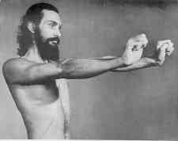

POSTURE : Stand with feet close together, with the body straight. Stretch out
your two arms straight in front of you at shoulder level,keeping them parallel
to the ground. EXERCISE `A' : With loosely clenched fists,let your wrists move
the fists up and down with force. While bringing your fist up and down, try to
touch the forearm. The arms should be kept as stiff as possible. Five times
to begin with. EXERCISE `B' : Raise the arms, bent at the elbow, sideways to
shoulder level.The wrists should be moved up and down as in exercise `A'.While
doing so, the fists should try to touch the forearm. Five times to begin with.

10. Kara-prashtha Shakti Vikasaka (Developing the back of the hand)

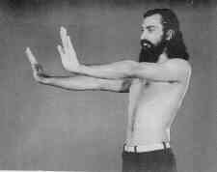

POSTURE : Keep feet together, the body straight, the arms stretch out in front
parallel to the ground, at shoulder level. Palms open and the fingers close
together. EXERCISE `A' :Move your wrists up and down with force while bringing
your first up and down, try to touch the forearm. The arms should be kept as
stiff as possible. EXERCISE `B' : Raise the arms, bent at the elbow. Sideways
to shoulder level. The wrists should be moved up and down arms folded at the
elbows with palms open, fingers together.

11. Kara-tala Shakti Vikasaka (Developing the Palms)

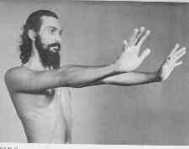

POSTURE : Keep your feet close together, the body straight. Stretch your arms
forward, with the fingers spread out as far as possible. The arms should be
kept parallel to the ground, at shoulder level. EXERCISE `A': From the wrists
let your hands move up and down vigorously. While bringing the palms up and
down the fingers must try to touch the arm. EXERCISE `B' : With the same pos-
ture, raise your arms sideways, bent at the elbows, keeping the fingers far
apart from each other, and move the hands up and down as if the fingers were
to touch the arm.

12. Anguli-mula Shakti Vikasaka (Developing the finger joints)

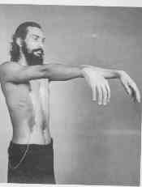

POSTURE : With the feet together and the body relaxed, raise the arms forward,
parallel to the ground, at shoulder level. The hands beyond the wrists should
be relaxed and drooping. EXERCISE `A' : While stiffening the entire arm, the
hand alone must be relaxed. Hold for five minutes to begin with.EXERCISE `B':
As at `A' but with the arms bent at the elbows. Two minutes to begin with.

13. Anguli Shakti Vikasaka (Strengthening the fingers)
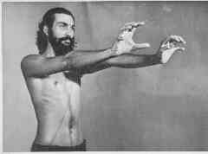

POSTURE : Stand with the feet close together and the body erect. Throw out
your arms in front,keeping them parallel to the ground at shoulder level.EXER-
CISE `A' : Let your fingers form the shape of the hood of a cobra, taking par-
ticular care to stiffen the entire length of the arms from the shoulder-joints
to finger-tips. The exercise will not be effective if enough force is not put
into it to make the arms tremble. Five minutes to begin with. EXERCISE `B' :
Posture the same as for `A'. Repeat the exercise `A',with the arms bent at the
elbows. The fingers should be spread in the shape of a cobra's hood.Five minu-
tes to begin with.

14. Bhuja-balli Shakti Vikasaka (Strengthening the forearms)

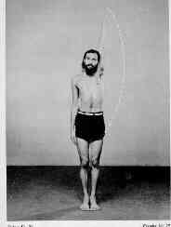

POSTURE : Feet together, the body straight, the arms by the sides. EXERCISE
`A' : Begin with your right arms. Let it hang relaxed; then raise it sideways
above your head with the palm outward. Bring it down in the same manner. The
arm must not touch the head when going up, or the thigh when coming down.Palms
must be open,with the fingers together. EXERCISE `B': Repeat the exercise with
your left arm. EXERCISE `C' : Now bring both arms into action. Both should go
up and come down together but the arms should not touch the head nor the hands
touch each other.

15. Purna-bhuja Shakti Vikasaka (Developing the arms)

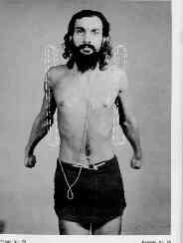

POSTURE : Keep the feet together, body erect, the hands clenched into fists
with the thumbs tucked in. EXERCISE `A' : Inhaling through the nose and hold-
ing your breath, swing your right arm forward and backward in a circle as many
times as you can. When you cannot hold your breath any longer stop with your
arm bent at the elbow and breathe out forcefully while thrusting your arm for-
ward at shoulder level. EXERCISE `B': Repeat the exercise `A' in reverse,swin-
ging the arm backward and then forward. EXERCISE `C' : Now repeat the exercise
`A' with the left arm. EXERCISE `D' : Repeat the exercise `B', with the left
arm. EXERCISE `E' : With both hands clenched into fists, let both your arms
describe a full upward circle, and exhale with a hissing sound. EXERCISE `F' :
The same as exercise `E' in reverse.This set of exercises tones up the nerves.
The arms and hands become more shapely. The entire length of the arm becomes
stronger.

16. Vaksha-sthala Shakti Vikasaka (Developing the chest) - [2]
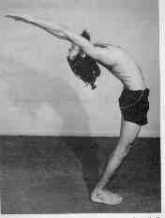

POSTURE : Stand with the feet together, body erect. Arms by your side, palms
turned backwards with the fingers together. EXERCISE : Swing back your arms,
describing a semi-circle. While doing this, inhale through the nose and lean
back as far as possible and remain in that position as long as your can.Exhale
slowly while reverting to the original position. Five times to begin with.This
exercise is helpful in many chest diseases.The chest expands and becomes stro-
ng. Tuberculosis,asthma and chronic bronchitis can be effectively tackled with
the help of this exercise. Persons suffering from weakness of the heart will
benefit by its tonic effect if they do this exercise for five minutes every
morning.
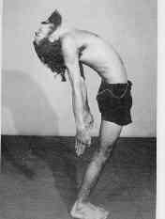

POSTURE : Stand with the feet together,body erect,arms by your side with palms
of the hands turned inwards. EXERCISE : While inhaling though the nose, bend
backward from the waist as far as you can go. At the same time raise your arms
behind you as high as you can. Maintaining this posture as long as you can,
exhale slowly while resuming your original position. Five times to begin with.
The advantages derived from this exercise are the same as from vakshasthala
saktivikasaka asana with the addition that this one gives vitality and streng-
th to the chest and back. The arms are also strengthened. Thin persons will
find their protruding bones covered with healthy flesh. Regular practice of
this exercise will keep the back straight throughout a man's life.

17. Udara Shakti Vikasaka (Developing the abdominal muscles) - [10]

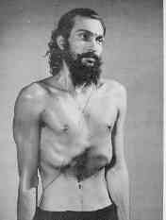
POSTURE : With the feet together, stand erect. EXERCISE : Inhale through the
nose slowly. While doing so, distend your abdomen as much as you can. After
holding the breath in this posture,release it slowly and gradually, while dra-
wing in the abdomen as much as you can, till it becomes hollow. This exercise
is also known as `Uddiyanabandha'.Practise this exercise repeatedly.Five times
to begin with. The `Yogacudamanupanisad' says about this particular exercise:
"Just as the bird who flies in the sky, in the Uddiyana posture, so does man
score a victory over death,like a lion over an elephant,thanks to the vitality
he receives from the Uddiyanabandha.
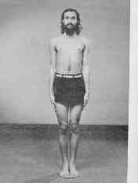
POSTURE : Stand erect with your feet together and your neck raised an inch
above the normal. EXERCISE : Breathing quickly and deeply through the nose
(Bellows effect) distend your abdomen, and while exhaling, contract it. 25
times to begin with. Particular care must be taken to distend and contract the
abdomen to the fullest extent; the inhaling and exhaling should be rhythmic.
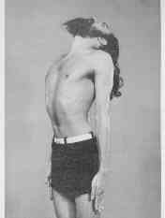
POSTURE : With your feet together, stand erect and bend your head as far as it
can go. EXERCISE : Breathe in and out quickly (Bellows effect)while distending
and contracting the stomach. 25 times to begin with.
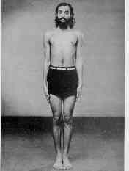
POSTURE : Stand erect with your feet together. Look at a spot four to five
feet forward your toes. EXERCISE : Inhale and exhale sharply (bellow effect)
distending and contracting your abdomen. 25 times to begin with.
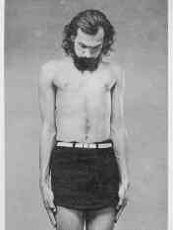
POSTURE : Stand with your feet together and the body erect. EXERCISE : Pouting
your lips suck in the air, and at the same time lower your chin to touch the
sternal notch. This exercise is also called Jalandharabandha.While holding the
breath, close your eyes and puff out the cheeks. Exhale so gradually through
the nose that there is no sound at all in doing so. If you have held your
breath for a considerable time, take particular care not to blow it out
voilently. That would be harmful. Five times to begin with.
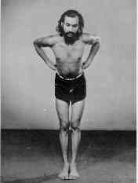
POSTURE : With your feet close together, stand erect. Bend the upper part of
your body forward at an angle of 60 degrees and place your hands on your hips
with the fingers at the back, thumbs front. EXERCISE:Inhale and exhale sharply
through the nose (Bellows effect) taking care at the same time to distend
and contract your abdomen. 25 times to begin with.
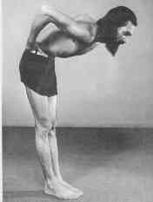
POSTURE : With your feet together, stand erect and hands on hips as in udara
satkivikasaka asana-6. Then bend forward to an angle of 90 degree. EXERCISE :
Inhale and exhale sharply (Bellows effect). While inhaling, the abdomen must
distend; while exhaling it must contract. 25 times to begin with.

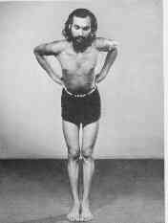
POSTURE : As in udara shaktivikasaka - 6. EXERCISE : Breathe out through the
nose and without breathing in distend and contract your abdomen in rapid
sccession. After you have held your breath to the fullest limit of your
endurance, breathe in slowly. Then breathe out and distend and contract your
abdomen again. Care should be taken to see that while you are busy exercising
your abdomen, your breathing remains suspended. Five times to begin with.
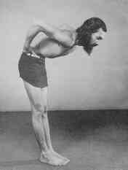
POSTURE : Udara shakti vikasaka - 7. EXERCISE : As in udara saktivikasaka - 8
For the purpose of this exercise, the entire operation of rapidly distending
and contracting the abdomen with suspended breathing is to be treated as a
single exercise. Therefore, five times means that the whole operation is
reputed five times over
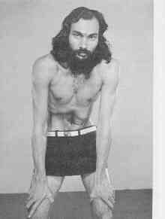

POSTURE : With feet two feet apart, place your hands on your knees and bend
from the waist to form an angle of 90 degrees. EXERCISE : Exhale completely.
Then contract your abdomen to the fullest extent. This is called the complete
Uddiyana. This done, stiffen the arms and allow the Nauli to stand out. Try
to rotate it right and left, describing a circle. Five to begin with. The
Nauli is the recti abdominis which form the front linear wall of the abdominal
cavity. The exercises for the abdomen depend for their efficacy on three
processes:1. Muscular contraction of parietal abdominal muscles specially the
rectus abdominis; 2. Stimulation of coeliac and plexuses of the autonomic
nervous system; and 3. Abdominal respiration.

18. Kati Shakti Vikasaka (Strengthening the back) - [5]
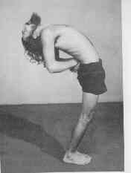
PSOTURE `A' : With your feet together, back straight, clench your right hand
to form a fist with the thumb tucked in. Holding it behind your back place
your left hand on the right wrist, both in contact with the back. EXERCISE `A'
Breathe deeply through the nose while bending backward as far as you can.
Maintain this posture for a few moments. Then, while exhaling,bend forward and
try to touch your knees with your head. Repeat this operation several times.
Five times to begin with. POSTURE `B' : As above except that the left hand
should be formed into a fist with the right hand on the left wrist. EXERCISE
`B' : As in Exercise `A'.
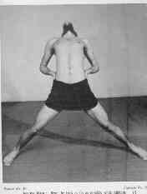
POSTURE : With your legs stretched apart as far as possible. Arms on hips,
keeping the fingers to the rear, and the thumbs in front. EXERCISE:Inhaling,
bend back from the waist as far as you can go. Maintain this posture for some
time. Then, while bending forward to touch the ground with your head, exhale
gradually. Five times to begin with.
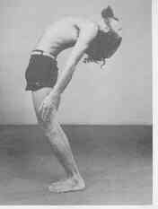
POSTURE : With your feet together, stand erect. EXERCISE : Inhaling, bend back
with a jerk as far as you can. Exhaling, bend forward with a jerk trying to
touch your knees with your head. Take care that during this exercise your
hand do not touch your thighs or your knees.
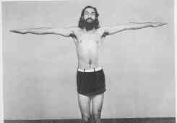
POSTURE : With your feet together, stand erect with your arms stretched out
sideways. EXERCISE : With your arms spread out, bend the trunk to your lef, as
far as you can and return slowly to the normal position. Then bend towards
your right. Five times to begin with. While doing this exercise, particular
care should be taken to see that your arms do not move up or down and that the
trunk does not bend forward or backward. At the same time while bending to
right or left you must stretch so that the hand touches the calf. Repeat the
exercise with your feet two feet apart. Five times to begin with.
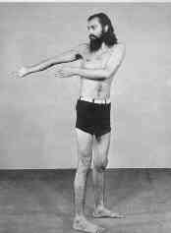
POSTURE : Stand with your feet two feet apart. EXERCISE : While inhaling
quickly,swing the trunk and the outstretched arms to describe a semi-circle to
the right and exhale. Repeat the process, this time exhaling with the trunk
turned to the left. Repeat this operation ten times to begin with. The five
exercises for the back make it supple and symmetrical. Regular practice remo-
ves all minor deformities of the back. Men and women under twenty-five can add
to their height, while those between twenty-five and thirty will also find
themselves taller than when they started. It is a boon for short persons.These
exercises are specially good for strengthening the back. Artists, actors and
actresses will find them of great help. A short course of these exercise will
add several inches to the chest and take away many more form a flabby, back,
while regular practice will make the body symmetrical and strong.

19. Muladhar-Chakra Shuddhi (Toning up the bowels and Muladhar chakra)

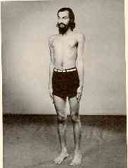

POSTURE : Stand erect with feet together, the thighs pressed together and the
neck relaxed. EXERCISE : With the buttocks pressed rigidly together contract
themselves of the rectum as if drawing in air through it. The breathing can be
normal though, in fact, this exercise generally results in the suspension of
breathing and the very violence of the effort makes the body tremble. Five
minutes to begin with.Since this exercise is for the internal organs no illus-
tration is possible. Repeat the exercise with the feet seperated by about 2-3
inches. Five minutes to begin with. The Upanisads say of this particular
exercise : "The drawing up of air through the rectum, Apana, results in the
elimination of the products of the kidneys and the bowels, and slenderness
replaces flabbiness."

20. Jangha Shakti Vikasaka (Developing the thighs) - [2]

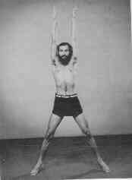

POSTURE : Stand erect with your feet together. EXERCISE `A' : Inhale through
the nose and at the same time throw up your arms while jumping up with your
feet together and coming down on your toes with feet apart. While exhaling,
lower your arms, while jumping up and coming down on your toes with your feet
together. Care should be taken to see that when coming down your arms do not
touch thighs, nor should your legs bend at the knees. EXERCISE `B' : The same
as at `A' but the entire operation being in reverse. In the earlier exercise
you inhaled when the arms were thrown up; in this one you should inhale when
bringing them down, and exhale when throwing them up. 25 times to begin with.

POSTURE `A' : With the feet together, stand erect. EXERCISE `A' : Inhaling
through the nose bend your knees gradually, with your arms held out before you
parallel to the ground. Stop when your thighs are parallel to the ground and
try to maintain this position as long as you can. Take care to prevent the
heels or the toes from rising from the ground. The knees must be together.
Then begin to rise gradually, while exhaling. If in the beginning you find it
difficult to hold your breath while doing this exercise, you can breathe nor-
mally, until, with sufficient practice, you can hold your breath. POSTURE `B':
With your feet together, heels raised, body erect, spread your arms sideways,
throwing your entire weight on the toes. EXERCISE `B' : Breathing in and
spreading you knees apart bend your knees but without sitting on your heels.
While in this position, hold your breath as long as you can. While rising
exhale slowly, Breathe normally to begin with, if it is difficult to hold your
breath. five times to begin with. These exercise develop the thighs and make
them shapely. You can cover long distances without tiring. Thin limbs acquire
healthy flesh, while flabby ones get rid of the superfluous flesh. Within a
very short time benefits of a lasting nature are noticed.
21.Janu Shakti Vikasaka (Strengthening the knees)
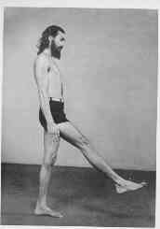
POSTURE : With the feet together stand erect. EXERCISE : Raise your foot for-
ward with a jerk of the knee and then raise it backward and repeat while keep-
ing the upper part of your body in the same erect position. After doing this
exercise with one leg, repeat it with the other. When taking your leg back,
the heel must touch the buttock. Ten times to begin with. This exercise is
good for rheumatic condition of the knees at it improves the circulation of
blood in the region. It is particularly efficacious for football players.

22. Pindala Shakti Vikasaka (Yogic squats for strengthening the calves)
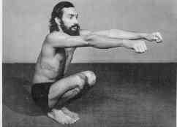

POSTURE : With your feet together, stand erect, your hands clenched into fists
your neck relaxed. EXERCISE : While inhaling through the nose,squat with your
arms held out in front of you, keeping them parallel to the ground. Your feet
should remain on the ground, with your knees closed. Go down as far as you can
Holding your breath, stand up while your arms describe one full circle as in
udarasakti vikasakasana and, on completing the circle, they should be held
before your chest, arms bent at elbows, fists touching each other. Then exhale
sharply while expanding the chest and pulling the arms slightly backward.

23. Gulpha-pada Prashtha-pada-tala Shakti Vikasaka (Developing the strength of ankles and feet)
POSTURE : With the feet together, stand erect. EXERCISE : Stretching forward
one foot and holding it about 9 inches off the ground, describe a circle first
from right to left, then from left to right, with the ankle. Repeat with the
other foot. Ten times to begin with. The exercise relieves rheumatism of the
ankles and strengthens the toes and the feet

24. Pada-mula and Padanguli Shakti Vikasaka (Developing the strength of the soles and toes)
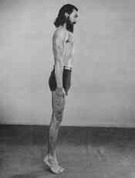
POSTURE : Stand on your toes, body erect and relaxed. EXERCISE `A' : Throwing
the weight of your body on the toes,raise and lower you body in a spring like
motion. The heels and toes should be together throughout. 25 times to begin
with. EXERCISE `B' : Balancing on the toes, jump up as high as you can, coming
down on the toes. During this operation the toes should be used to maximum
effect. Care should also be taken to maintain the original position of contact
between the heels and the toes, and to bring them down on the spot from
which you jumped. 25 times to begin with. These exercises give the calves
strength and symmetry, rheumatic conditions are cured. The calves become firm
and the soles of the feet strong.
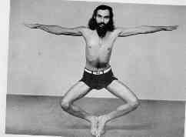
POSTURE : Stand with the feet together, body erect and relaxed, and your arms
spread out. EXERCISE : With the toes held together, throw the entire weight
of the body on your tips. Try to maintain your balance in this position as
long as you can. Three minutes to begin with. This exercise strengthens the
feet and the toes and their joints. Deformed toes improve in appearance. Those
interested in running will derive much benefit from this exercise. Specially
recommended to inhabitants of hilly area.This exercise makes the toes elastic.
After completing all the 48 exercises, you must assume the `corpse pose'(Sava-
sana). This is nothing but giving your body complete rest while lying down. It
makes the blood flow through the body in an even course,and the fatigued limbs
are refreshed. Maintain this posture till your breathing and your heart-beat
are normal once again.

25. Rekha Gati (Walking in a straight line)

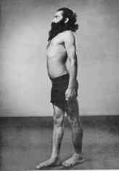

POSTURE : With the left foot on the ground, place your right foot in front of
it so that the right heel touches the toes of the left foot. EXERCISE : Now
walk fifty steps ahead with the heel of one foot touching the toes of the
other, taking care to see that the entire distance is covered in a straight
line. Then walk backward, in the same manner and in a straight line. The eyes
must look front and not at the feet. This exercise increases the power of con-
centration and improves the balance of the body. It is of special benefit to
acrobats and to persons in the army or the police force. Regular practice of
this exercise makes it possible to walk on a thin rope.

